**CHEF: 4 weeks**

What is vagrant?

What is Configuration management in the **Pull model**?

How to create servers in AWS?

Chef:

**What is vagrant?**

**Vagrant is an open-source tool for creating and managing virtual machine environments. It provides a simple and consistent way to set up and configure development environments, making it easier for developers to collaborate and work on projects.** Vagrant allows you to define your development environment as code using a declarative configuration file, which can be shared and version-controlled.

With Vagrant, you can create lightweight, reproducible, and portable virtual machines that closely resemble your production environment. It supports various virtualization providers such as VirtualBox, VMware, and Hyper-V, allowing you to choose the one that best suits your needs.

By using Vagrant, you can automate the setup of complex development environments, including provisioning software, configuring networking, and managing dependencies. It helps eliminate the "it works on my machine" problem by providing a consistent environment for all team members.

Vagrant integrates well with configuration management tools like Puppet, Chef, and Ansible, enabling you to automate the setup and configuration of software within the virtual machine. It also supports the creation of multi-machine environments, allowing you to define complex setups with multiple interconnected virtual machines.

Overall, Vagrant simplifies the process of creating and managing virtual development environments, promoting collaboration and reproducibility among developers.

Top of Form

Bottom of Form

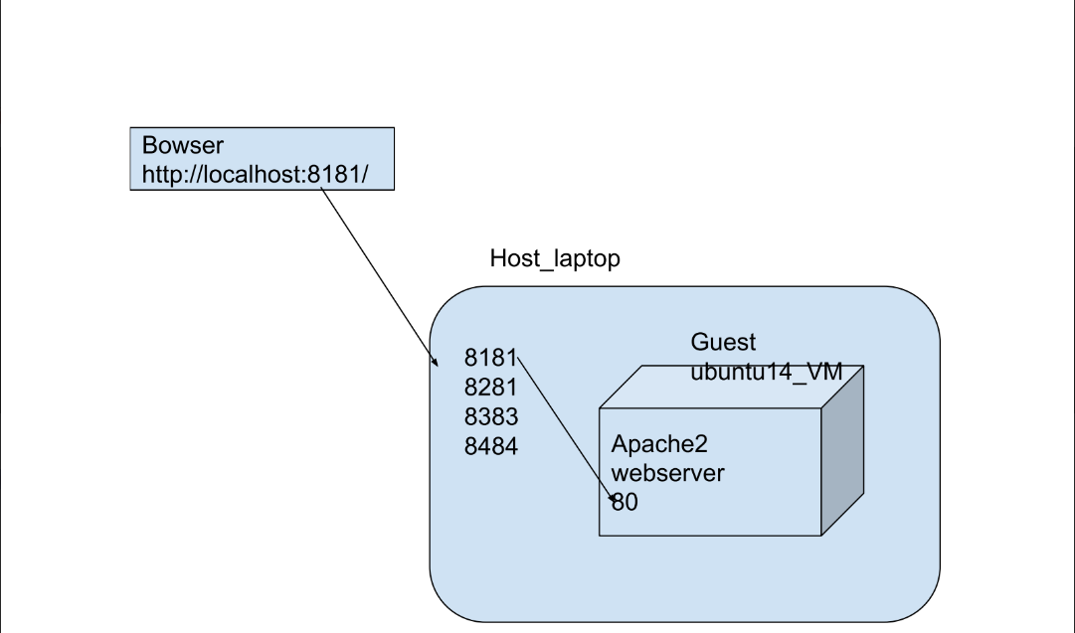

● Vagrant is a Virtual provision tool

● We can create Vm on your laptop very easily

**By Traditional:**

We are not following

**By Vagrant:**

1) Install VirtualBox on your laptop

2) Install git bash on your laptop

3) Install Vagrant on your laptop

4) Create a folder on your laptop

5) Open folder and open git bash and execute below commands

**vagrant init ubuntu/trusty64**

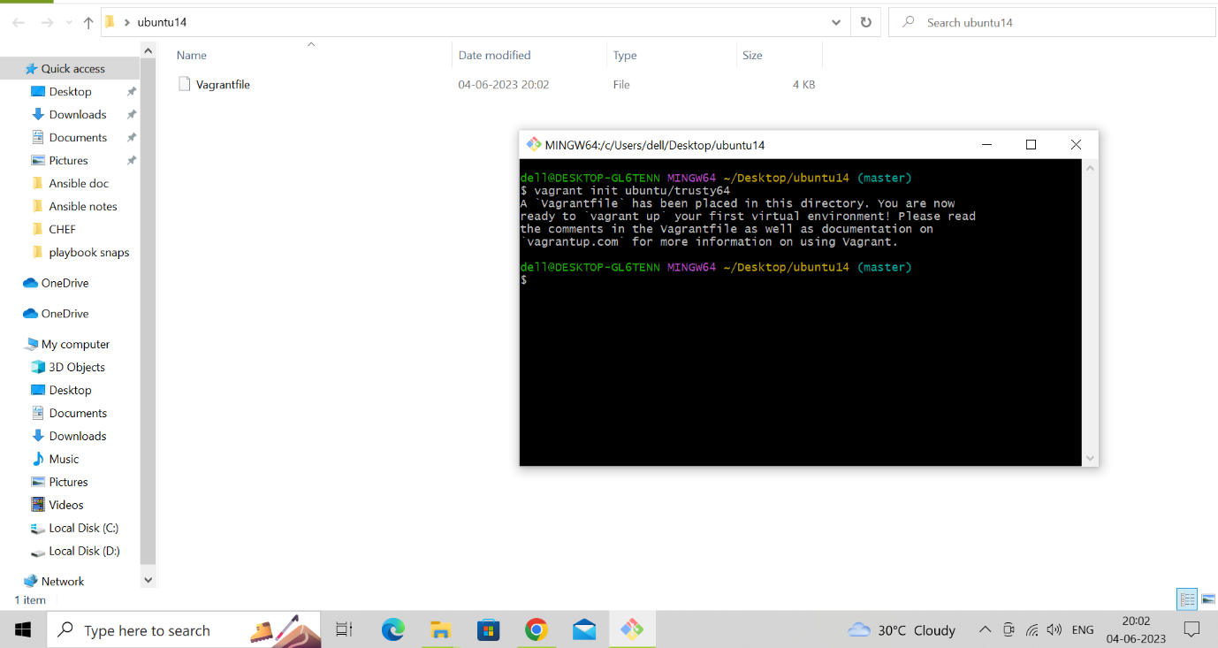

**vagrant up**

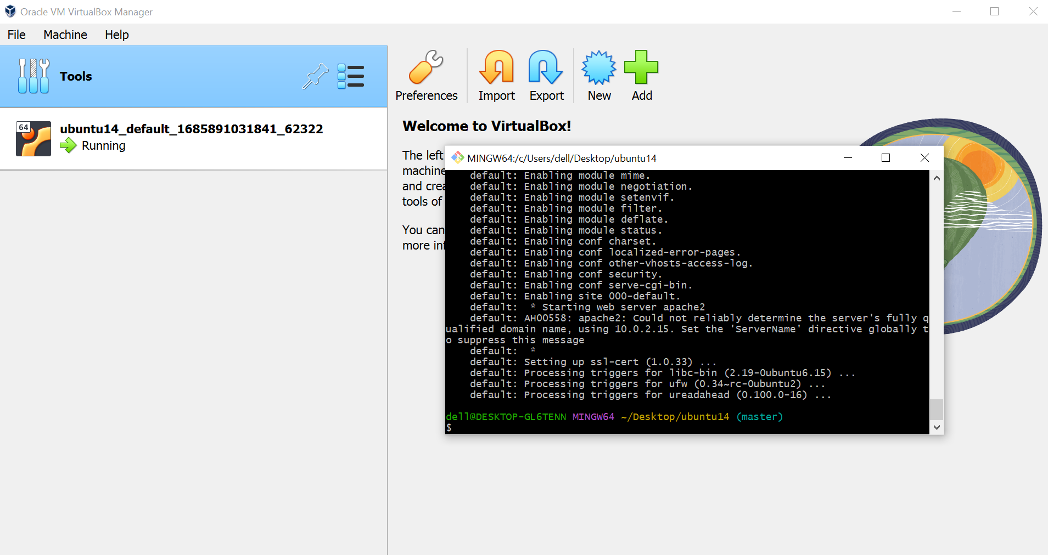

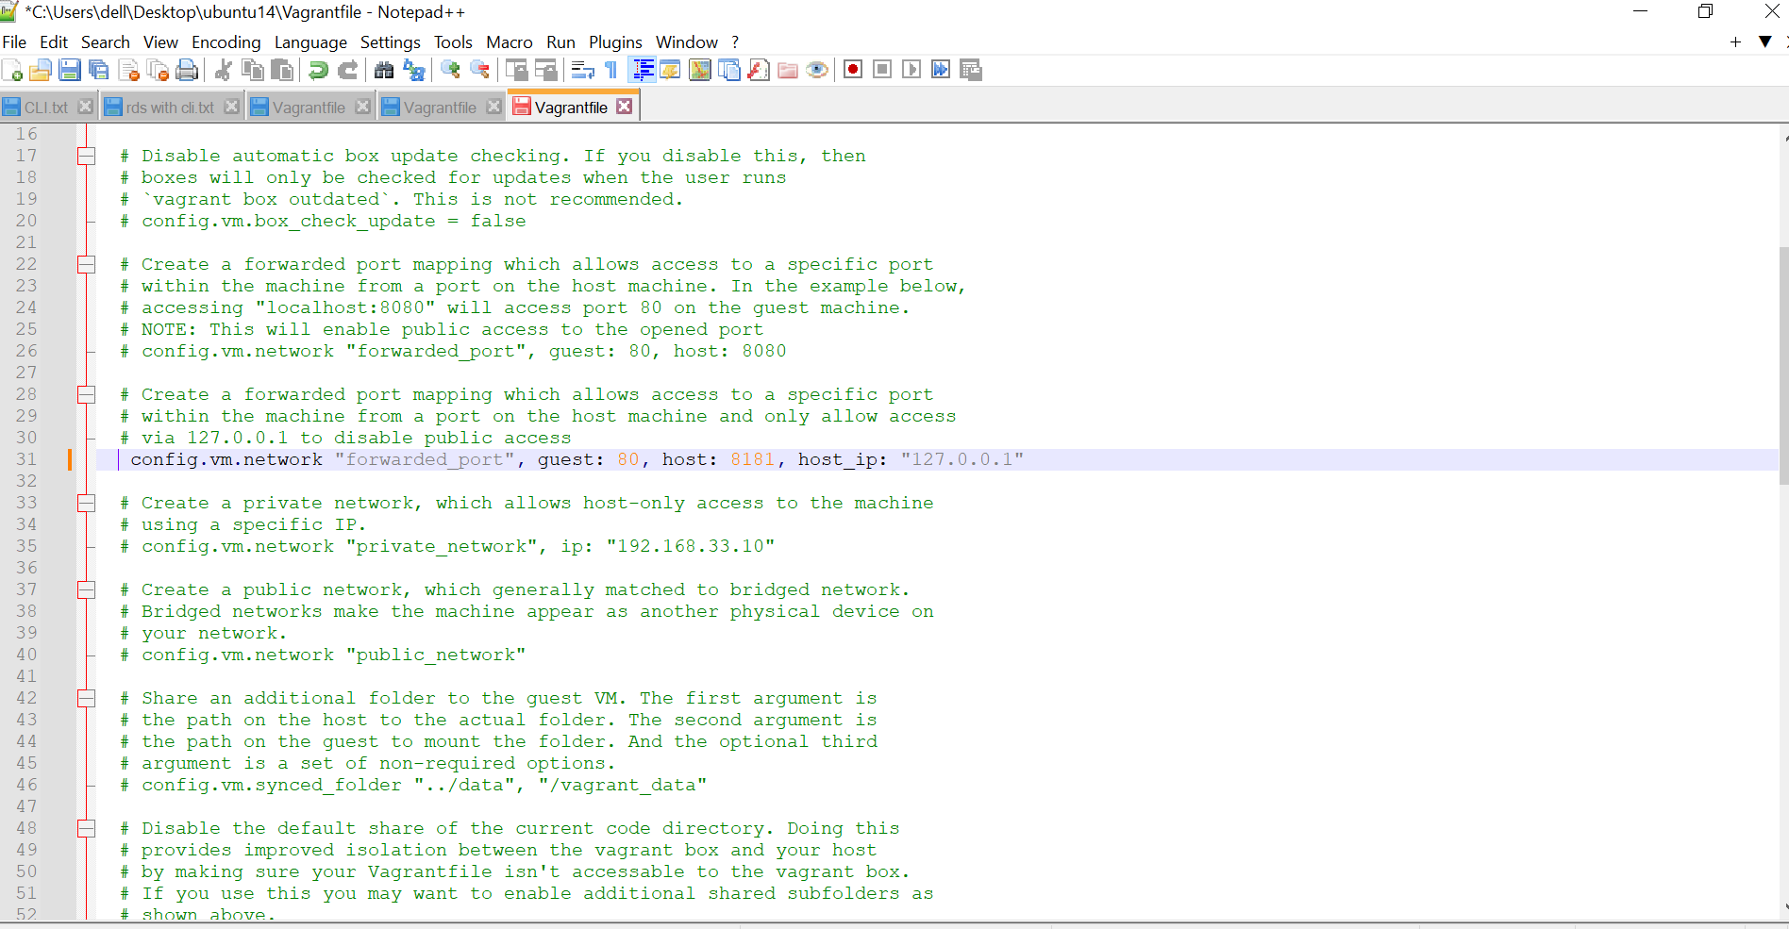

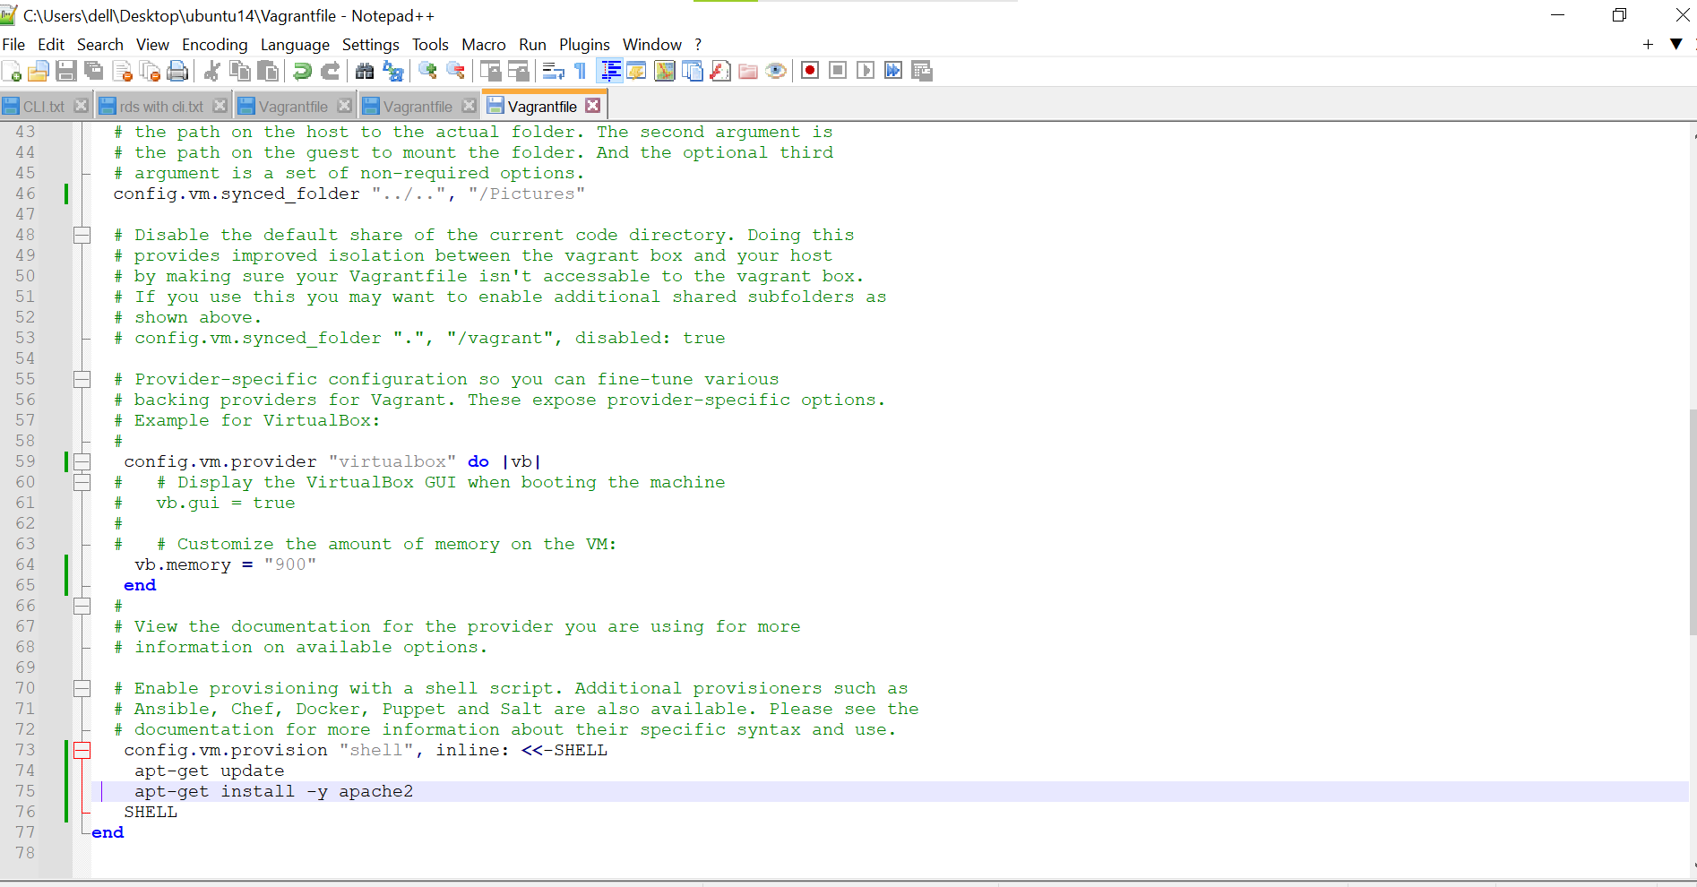

**vagrant ssh**

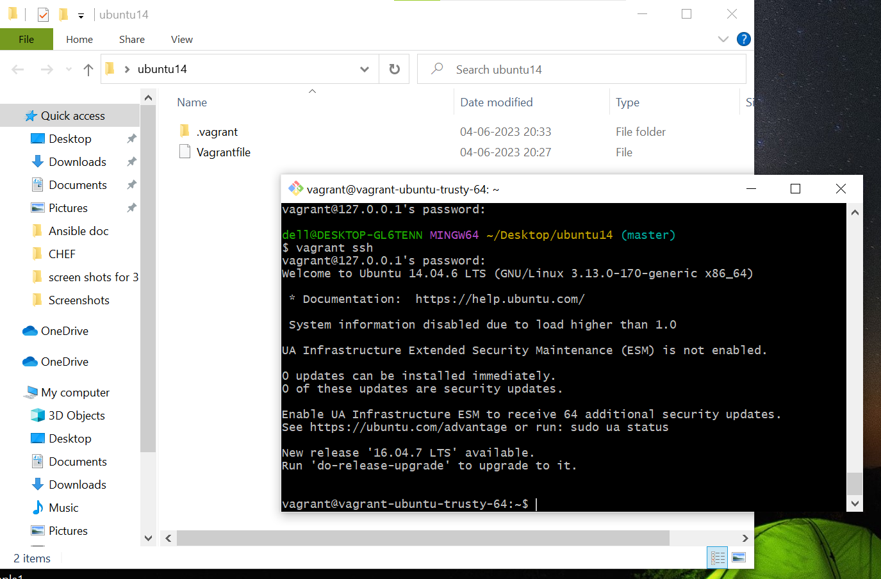

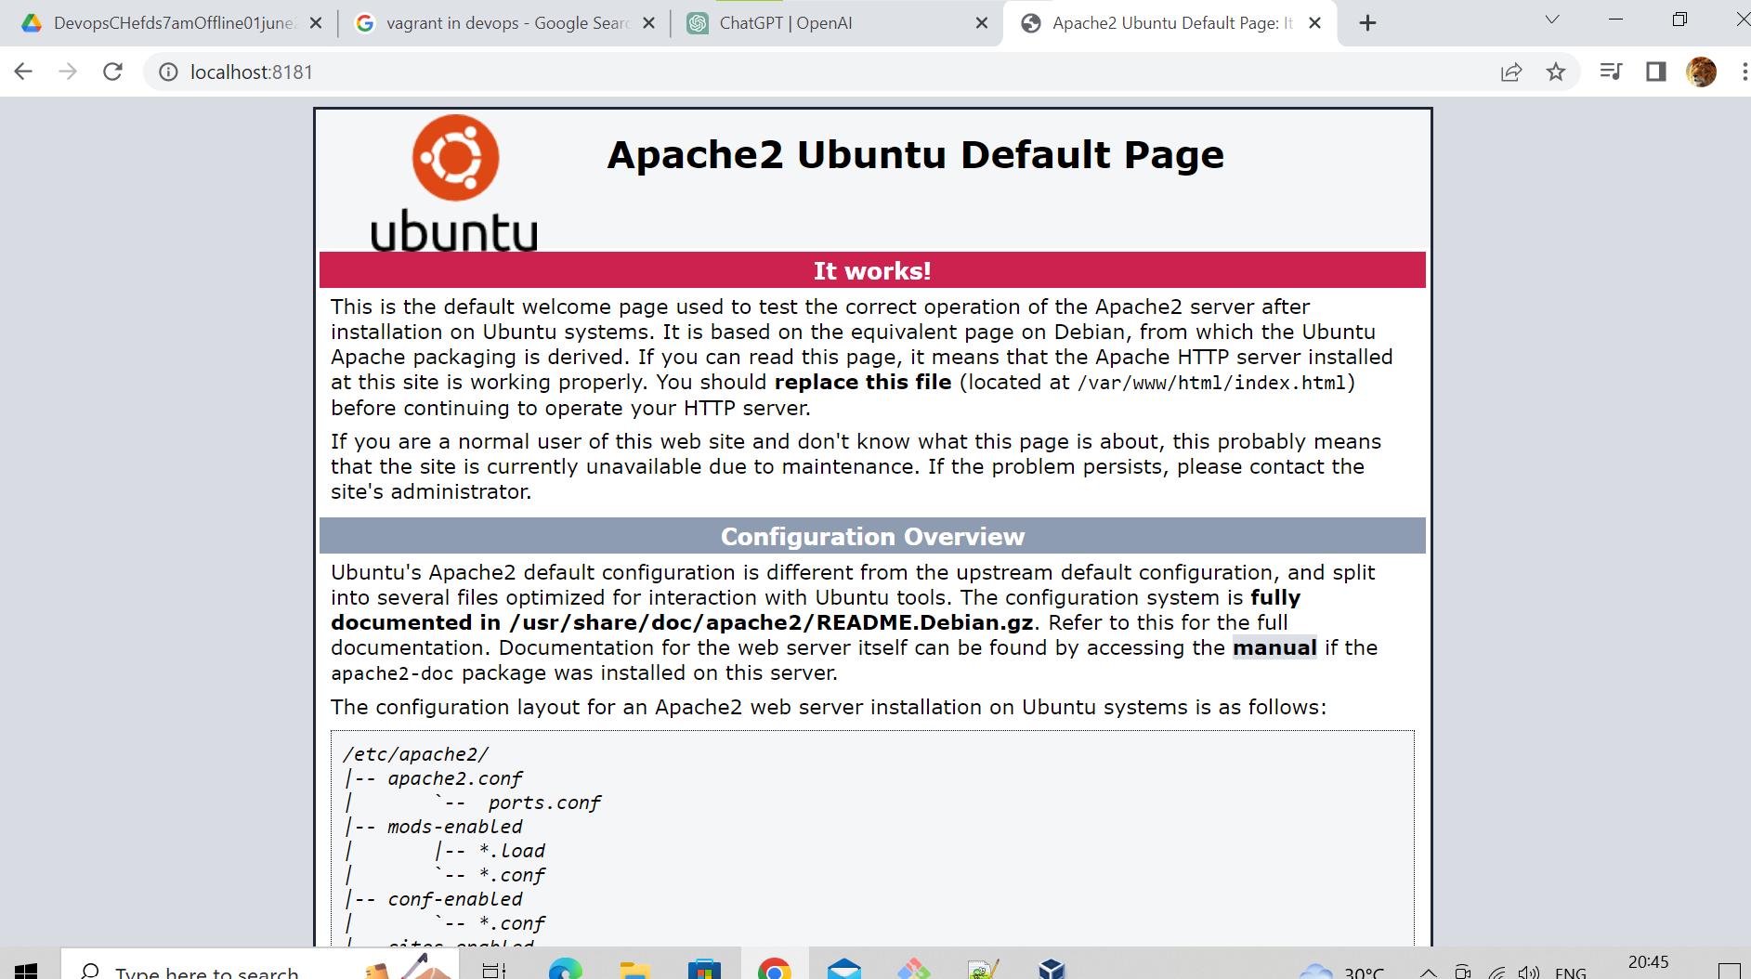

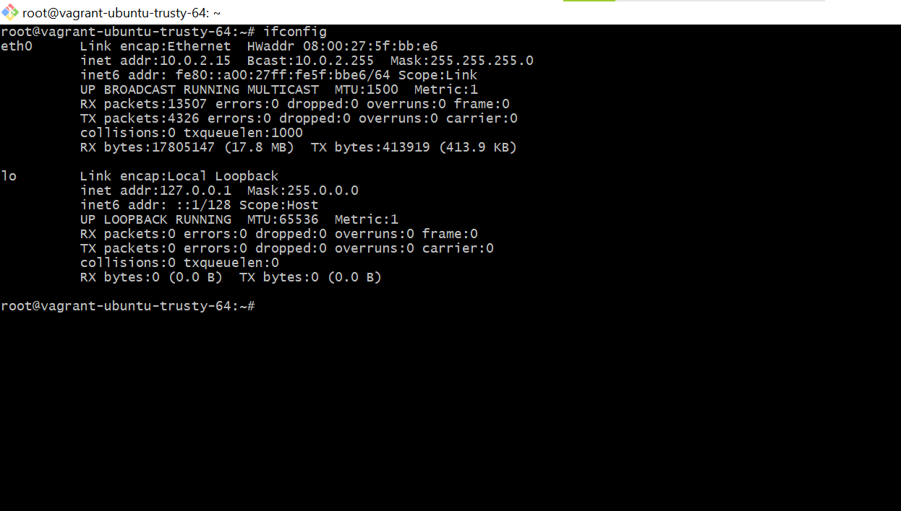

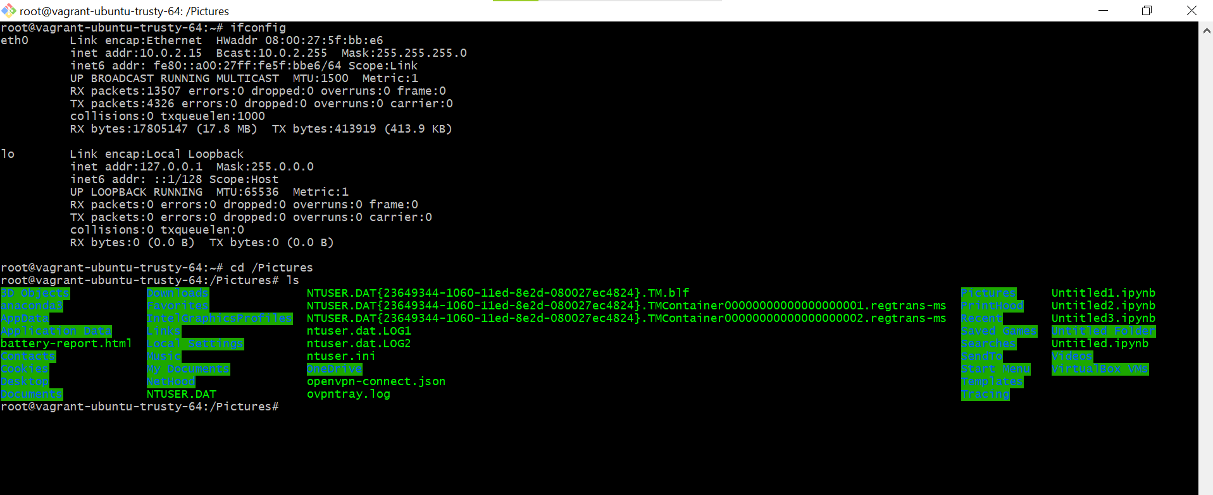

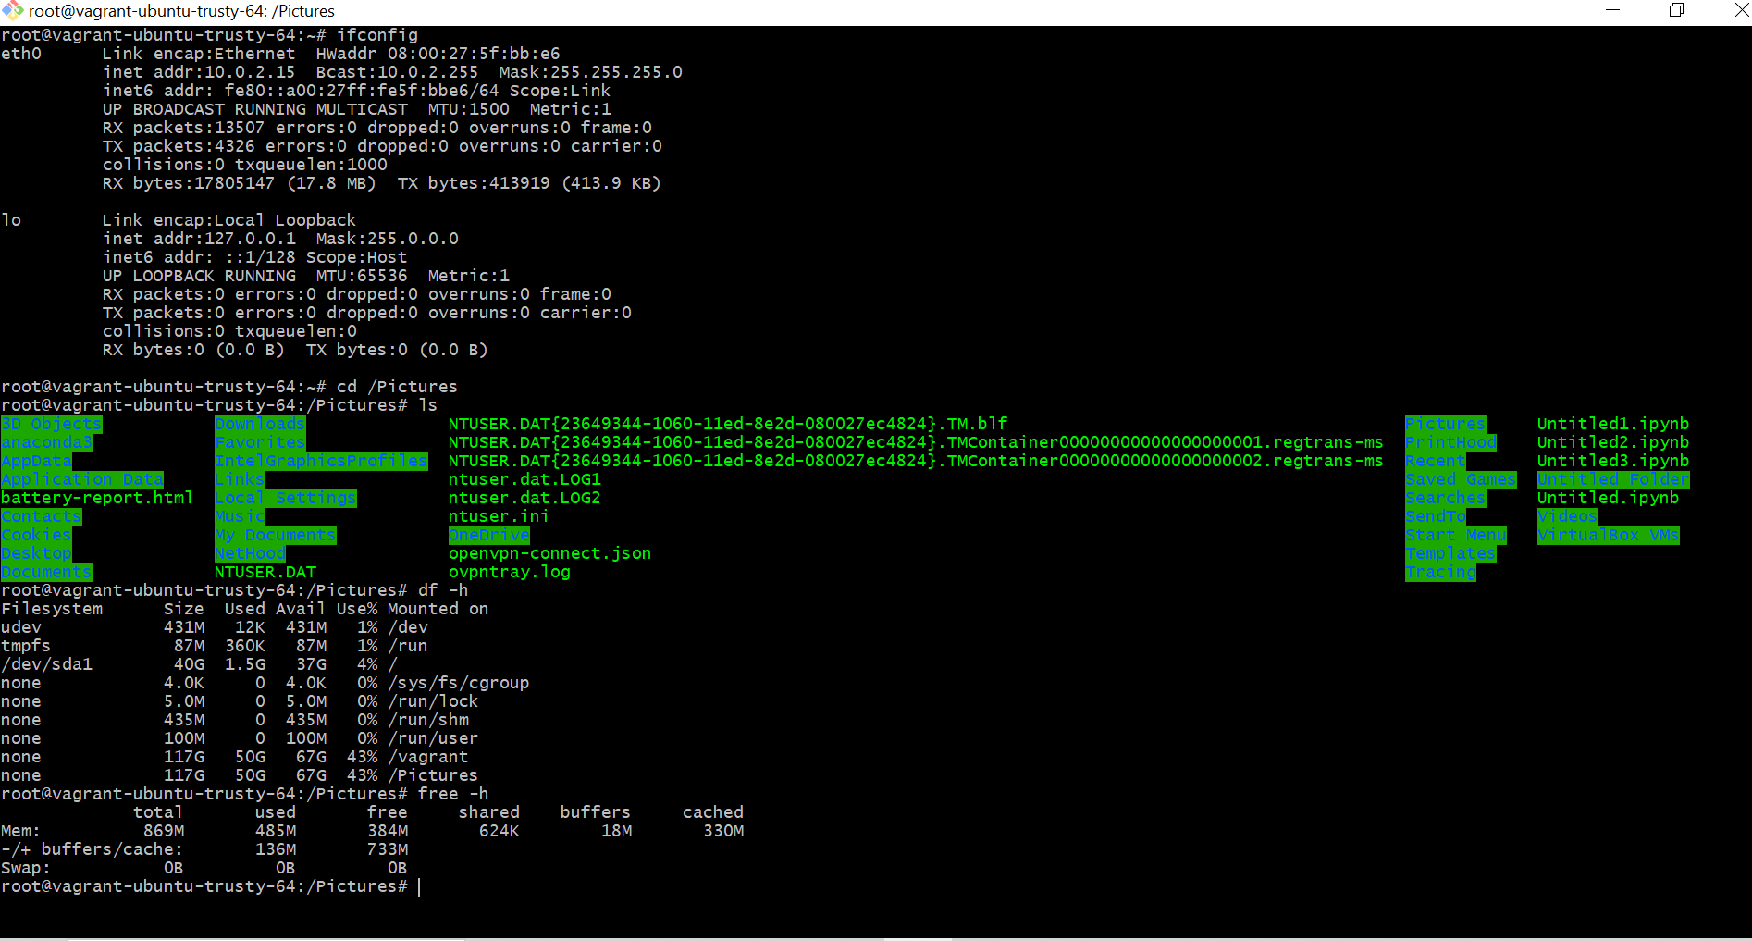

**Vagrant destroy**

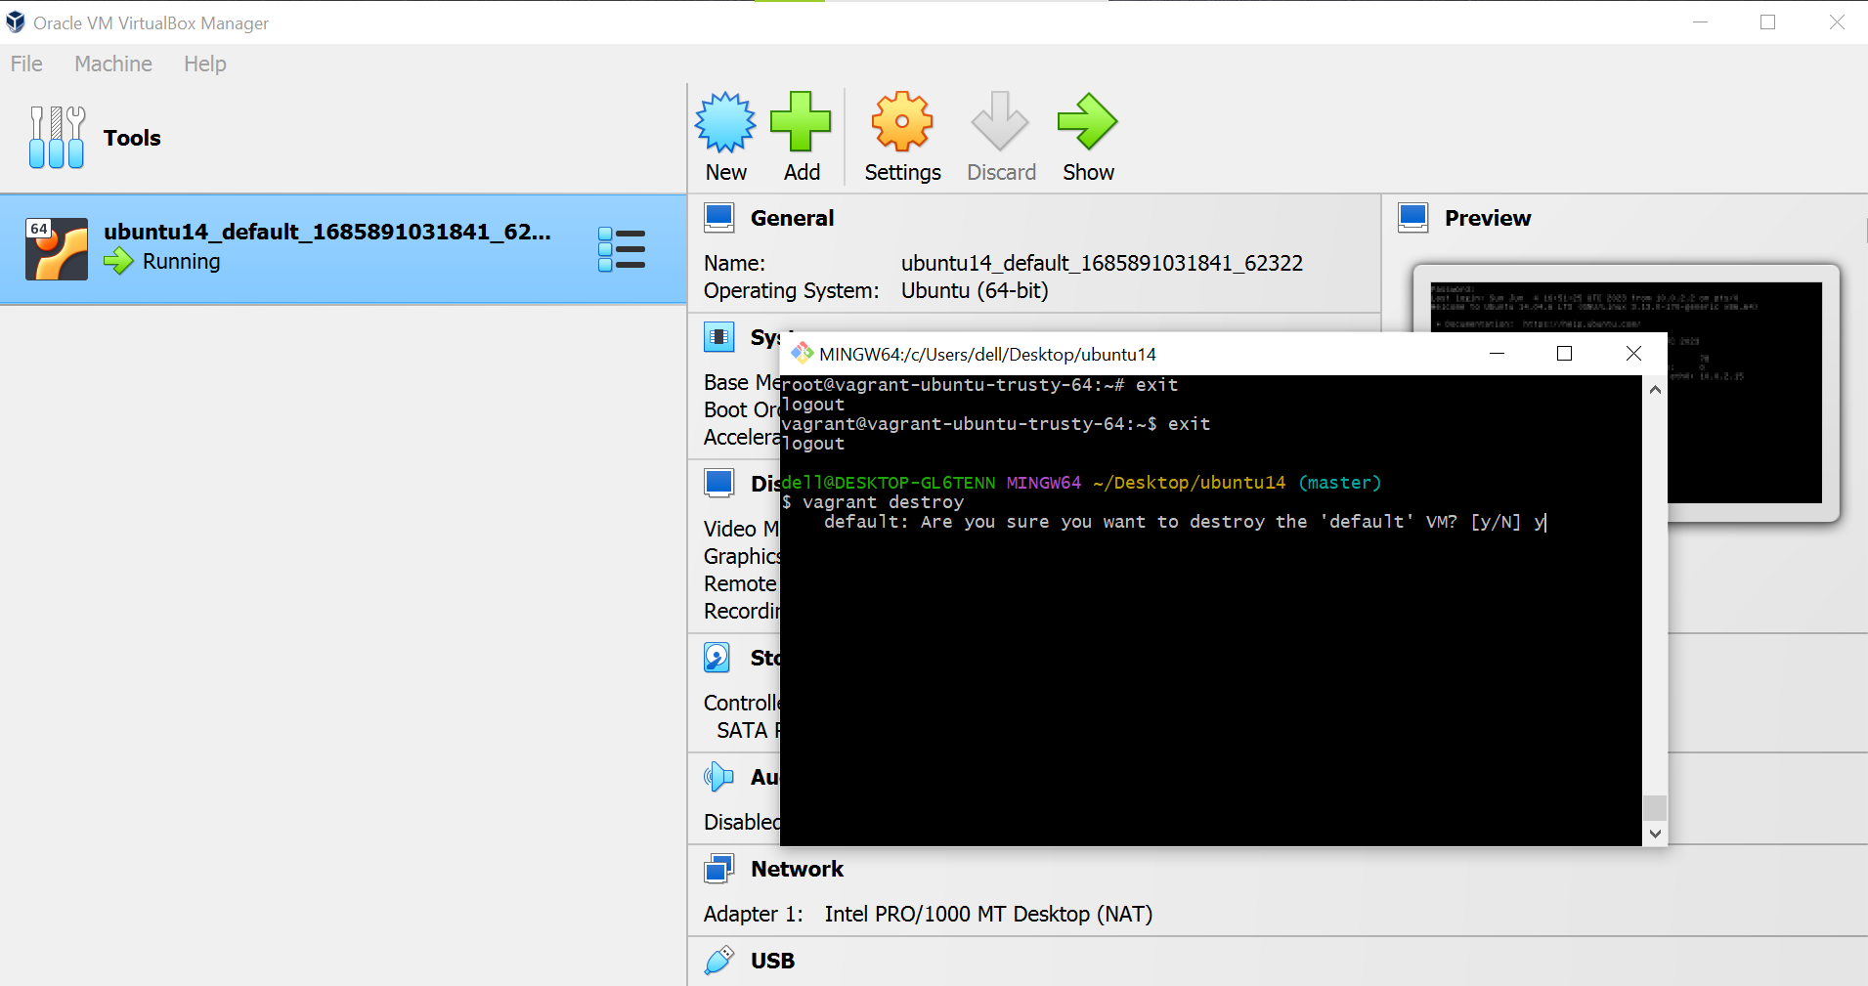

**2) What is Configuration management in the Pull model?**

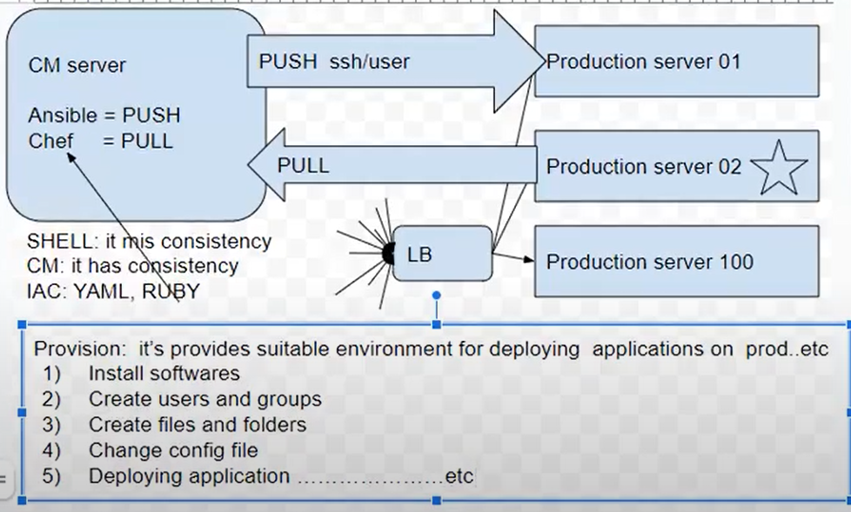

**PULL:**

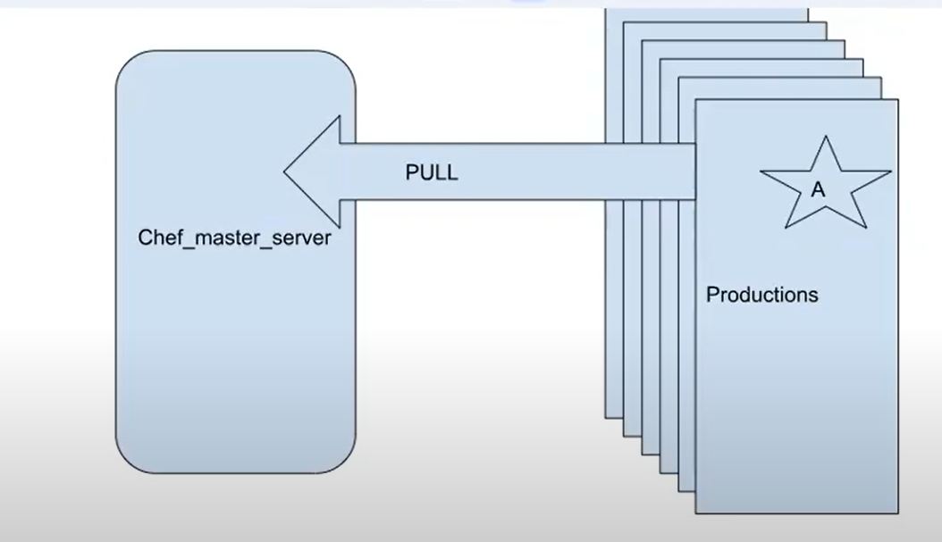

**Workstation (your laptop)**

**Chef server (install or hosted chef server)**

**Chef client (aws ec2 servers)**

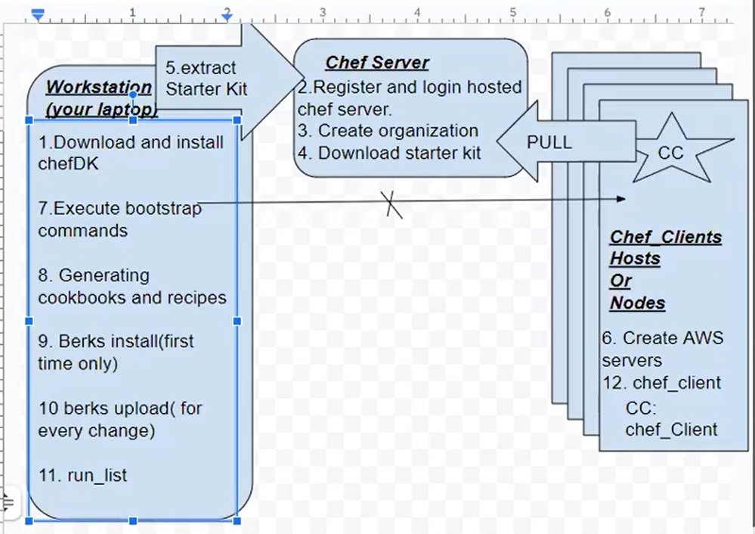

D:\devops\chef\mychef11june2023\chef-repo

**knife bootstrap <public ip of node> --ssh <username> --sudo --identity-file<your server pem location> -N <your chef node name>**

knife bootstrap 18.118.166.69 --ssh-user ubuntu --sudo --identity-file "C:\Users\dell\Desktop\myvpnkey.pem" -N mychefnode01

D:\devops\chef\mychef11june2023\chef-repo\cookbooks

Chef generate cookbook < my cookbook name>

Chef generate cookbook myfirstcookbook

D:\devops\chef\mychef11june2023\chef-repo\cookbooks\myfirstcookbook

berks install (it is one time only)

berks upload



